CHRISTENSEN, ALEXANDER P., M.A. Remotely Close Associations: Openness to Experience and Semantic Memory Structure. (2017)
Directed by Dr. Paul J. Silvia. 72 pp.
Openness to experience—the enjoyment of novel experiences, ideas, and unconventional perspectives—has shown several connections to cognition that suggest open people might have different cognitive processes than those low in openness. People high in openness are more creative, have broader general knowledge, and show greater cognitive flexibility. The associative structure of semantic memory might be one such cognitive process that people in openness differ in. In this study, 497 people completed a measure of openness to experience and verbal fluency. Three groups of high (n = 115), moderate (n = 121), and low (n = 118) openness were created to construct semantic networks—graphical models of semantic associations that provide quantifiable representations of how these associations are organized—from their verbal fluency responses. The groups were compared on graph theory measures of their respective semantic networks. The semantic network analysis revealed that as openness increased, the rigidity of the semantic structure decreased and the interconnectivity increased, suggesting greater flexibility of associations. Semantic structure also became more condensed and had better integration, which facilitates open people’s ability to reach more unique associations. These results were supported by open people coming up with more individual and unique responses, starting with less conventional responses, and having a flatter frequency proportion slope than less open people. In summary, the semantic network structure of people high in openness to experience supports the retrieval of remote concepts via short associative pathways, which promotes unique combinations of disparate concepts that are key for creative cognition.

REMOTELY CLOSE ASSOCIATIONS: OPENNESS
TO EXPERIENCE AND SEMANTIC
MEMORY STRUCTURE

by
Alexander P. Christensen

A Thesis Submitted to
the Faculty of The Graduate School at
The University of North Carolina at Greensboro
in Partial Fulfillment
of the Requirements for the Degree
Master of Arts

Greensboro
2017

Approved by

Dr. Paul J. Silvia
_____________________________
Committee Chair

APPROVAL PAGE
This thesis written by ALEXANDER P. CHRISTENSEN has been approved by the following committee of the Faculty of The Graduate School at the University of North Carolina at Greensboro.

Dr. Paul J. Silvia
Committee Chair___________________________
Dr. Thanujeni Pathman
Committee Members___________________________
Dr. Peter F. Delaney
___________________________

08/25/2017
____________________________
Date of Acceptance by Committee
08/25/2017
__________________________
Date of Final Oral Examination

TABLE OF CONTENTS
Page
LIST OF TABLES v
LIST OF FIGURES vi
CHAPTER
I. INTRODUCTION 1
Semantic Networks 2
Openness to Experience, Cognition, and Semantic Memory 7
The Present Research 16
II. METHOD 20
Participants 20
Materials 21
Procedure 24
Statistical Approach 25
III. RESULTS 28
Behavioral Analyses 28
Individual and Unique Fluency Responses 29
Early Common Responses 29
Preprocessing for Network Analysis 30
Association Slope 31
Network Analysis 32
Bootstrapped Partial Network Analysis 33
IV. DISCUSSION 36
Network Analysis 37
Bootstrapped Partial Network Analysis 38
Association Slope 41
Early Common Responses 42
Unique Responses 43
Individual Responses 44
Limitations and Future Directions 44
Conclusion 46
REFERENCES 47
APPENDIX A. TABLES 64
APPENDIX B. FIGURES 68
LIST OF TABLES
Page
Table 1. Hypotheses for the Network Measures 64
Table 2. Descriptive Statistics 65
Table 3. Unique Responses from the Openness Groups 66
Table 4. Full Semantic Network Statistics 67

LIST OF FIGURES
Page
Figure 1. Example of Network Types 68
Figure 2. High and Low Creative Semantic Networks 69
Figure 3. Association Slope Across and Within-Groups 70
Figure 4. Full Semantic Network Structure of Each Group 71
Figure 5. Bootstrapped Partial Network ANOVAs 72
CHAPTER I
INTRODUCTION
Why are open people creative? There’s a wealth of research that supports the relationship between the Big Five dimension of openness to experience (hereafter, openness) and creativity. But only a handful of studies have investigated possible processes that facilitate their association. For instance, open people have a general tendency to explore and diversify experiences (DeYoung, 2014), which has been shown to enhance cognitive flexibility—the ability to break old cognitive patterns, overcome functional fixedness, and make novel associations between concepts (Guilford, 1967; Ritter et al., 2012). Moreover, other factors, such as the motivation to learn and obtain broad general knowledge, also contribute to the connections between openness and creativity.
So far, few studies have examined underlying cognitive factors—such as the organization of memory—that might support their association. Recent research has investigated the structure of semantic memory and found that creative people have more flexible, interconnected associations between concepts than people who are less creative (Kenett, Anaki, & Faust, 2014). Given these findings, the structure of semantic memory might be a cognitive factor that is also linked to openness to experience. Thus, the present study compared the organization of semantic associations across high, moderate, and low levels of openness using a computational network approach.

Semantic Networks
Semantic memory is our knowledge about the world, such as word meanings, concepts, and categorization of facts (Jones, Willits, Dennis, & Jones, 2015). The structure of semantic memory was first investigated in a seminal paper by Collins and Quillian (1969), who found semantic memory was organized into hierarchical categories, starting from more general to increasingly specific exemplars. Their ideas set the foundation for semantic memory to be investigated as categorizations of within-level and between-level features, which have connections that extend across an association hierarchy. They proposed that semantic memory could be represented as a sprawling web of highly structured associations between concepts—like a network (Steyvers & Tenenbaum, 2005). Furthermore, Collins and Loftus (1975) theorized that search through semantic memory was the result of activated associations between concepts. Their theory of spreading activation suggests that the organization of associations can affect the efficiency of search and the amount of associations available in memory. Finally, Anderson (1983) proposed the ACT model, which suggests that cognitive units (e.g., semantic concepts) form an interconnected network where retrieval is supported by spreading activation throughout the network. Moreover, the level of activation determines the rate and probability of recall as well as the potential for interference of retrieval. In this way, associative strength and proximity indicate the likelihood a semantic concept will be retrieved from long-term memory.
Despite these pivotal experiments, the complexity of semantic relations has made measuring the structure of semantic memory a difficult problem. The development of network science and computational graph theory, however, has provided a way to make meaningful inferences into the organization of semantic memory by using web-like graphs to investigate the associations between concepts.
Over the last decade, networks have been used by an expanding number of scientific disciplines to model complex phenomena and to reveal underlying structure in otherwise large, chaotic sets of data (Barabási, 2012; Newman, 2010). In theory, a network is simple. A network is a graph with nodes—vertices—connected by edges—relations—to other nodes. In an undirected network, edges are bidirectional; in a directed network, relationships are directional. In addition to direction, edges can be weighted, which signifies the strength of a relationship between two nodes. In a semantic network, it’s common to represent a node as an exemplar of a category (e.g., an animal) or an association to a target word (e.g., spoon), and edges—undirected and unweighted—as the semantic relatedness between exemplars or word associations (Borge-Holthoefer & Arenas, 2010; De Deyne et al., 2016; Kenett et al., 2013). Connections between nodes in a network form paths, a sequence of associations from a starting node to an ending node, so that distances between nodes suggest relational differences in the network. The number of edges between two nodes is called a path length, which has important implications for network structure. Finally, cliques are connections between a set of three nodes that form a fully connected subgraph (i.e., a triangle).
There are many different ways to measure network structure that imply quantifiably different meanings. For example, macro measures examine organization of the entire network and characterize global features, while micro measures investigate the influence—the connections and positions—of individual nodes in the network (Boccaletti, Latora, Moreno, Chavez, & Hwang, 2006; Borge-Holthoefer & Arenas, 2010). For the purposes of this study, I’ll focus on macro measures and interpret their meaning with reference to semantic networks.
The average shortest path length (ASPL) is the mean distance between any two nodes in the network. The ASPL is often referred to as degrees of separation: lower values suggest greater interconnectivity between all nodes in the network (Watts & Strogatz, 1998). In semantic networks, short path lengths represent smaller distances between category exemplars like axolotl and albatross, while greater ASPL suggests greater distance between all exemplars (Faust & Kenett, 2014). Another important measure is the clustering coefficient (CC), which refers to the extent to which two neighbors of a node will be neighbors themselves—that is, whether two connected nodes will both be connected to a third node. In this way, the CC represents how “cliquish” the network is and indicates finer, more localized organization of semantic information.
Semantic networks range on these two measures of topology (i.e., ASPL and CC) from regular (ordered) to random (chaotic; Faust & Kenett, 2014). Regular networks have large clustering coefficients and high ASPL, with connections to their neighbors and their neighbors’ neighbors—referred to as a lattice. Random networks are poorly clustered (small CC) and mostly have cross-network connections characterized by small ASPL values. Networks that make up the intermediate spectrum are called “small-world” networks, which have large CC and small ASPL (Watts & Strogatz, 1998). For visual representation of regular, random, and small-world graphs, see Figure 1. Small-world networks have been reported in many phenomena, including semantic networks (Borge-Holthoefer & Arenas, 2010; Steyvers & Tenenbaum, 2005). A small-worldness measure can be computed by comparing the CC and the ASPL of the networks generated by the data to an equivalent random graph. The formula for small-worldness is expressed as:

$$S= \frac{\frac{CC}{CC \left(random\right)}}{\frac{ASPL}{ASPL(random)}}$$
Networks are considered “small-worlded” when this ratio is greater than one (Humphries & Gurney, 2008). In semantic networks, small-worldness (S) measures the degree to which the network has a high clustering coefficient and small ASPL. Higher S allows more flexibility and efficient access to associations in a semantic network, with more shortcuts between localized conceptual relations (Benedek, Kenett, Umdasch, Faust, & Neubauer, 2017; Borge-Holthoefer & Arenas, 2010). An increasing small-worldness measure without structure, however, reflects increasing “chaos” or randomness (Faust & Kenett, 2014; Kenett et al., 2016a). Thus, lower small-worldness suggests decreased flexibility and increased order between associations. Lower small-worldness, specifically higher ASPL, typically means a wider diameter (D) because connections are relatively limited in their cross-network connectivity and there is more distance between remote concepts. A small diameter suggests a tight, condensed network, which promotes shorter links between concepts in the network. In general, D, ASPL, and S measures are directly related.
Finally, modularity (Q) is a measure of network communities or compartmentalized sections of a network. Greater modularity suggests greater partitioning, which is represented by segregated groupings of nodes in the network (Newman, 2006). In a semantic network, these groupings suggest sub-categories of a larger category. For example, in a network of animals, sub-categories might be pets, neighborhood, and zoo animals. Therefore, modules signify meso—mid-level—structure (Borge-Holthoefer & Arenas, 2010). Higher modularity grants greater structure to a semantic network but at the cost of lower flexibility and more rigid categorizations, which is seen in some clinical samples (Faust & Kenett, 2014; Kenett, Gold, & Faust, 2016b). Therefore, modularity measures structural properties of the network as well as the rigidness of associations. In summary, an effective balance of structural (Q and ASPL) and chaotic (S) properties reflects optimal semantic integration between rigidity and randomness (Benedek et al., 2017; Faust & Kenett, 2014; Kenett et al., 2016a).
Semantic networks can help us understand the complex and convoluted organization of semantic memory structure (Borge-Holthoefer & Arenas, 2010; De Deyne et al., 2016; Steyvers & Tenenbaum, 2005). Semantic memory is an important function in human cognition that affects language, how we categorize information about the world, and our ability to recognize situations. Using network models, we can glean valuable inferences about the development of language, second languages, differences in cognition, and psychological disorder (Borodkin, Kenett, Faust, & Marshal, 2016; De Deyne et al., 2016; Kenett et al., 2016b; Steyvers & Tenenbaum, 2005; Vitevitch, Chan, & Roodenrys, 2012). Representing semantic information in networks allows us to ask many questions: What is the structure of semantic memory? Do semantic networks complement biological networks? Or, as I explore below, how does semantic memory structure relate to personality traits, specifically openness to experience?
Openness to Experience, Cognition, and Semantic Memory
Why would openness to experience be related to semantic memory? One reason is that openness to experience, more than any other personality trait, is linked to several different cognitive abilities such as intelligence, working memory, and creativity (DeYoung, 2014; DeYoung, Quilty, Peterson, & Gray, 2014; Kaufman et al., 2010). Indeed, in an examination of behavioral, affective, and cognitive processes related to Big Five personality traits, openness to experience was found to be epitomized by cognition (Zillig, Hemenover, & Dienstbier, 2002). Moreover, openness has also been linked to memory processes such as the experience and usage of autobiographical recollections (Rasmussen & Berntsen, 2010). The use of autobiographical recall has been shown to support the strategic search of semantic memory, allowing more efficient retrieval from long-term memory (Unsworth, Brewer, & Spillers, 2014).
Finally, there are theoretical connections that suggest there should be significant links between semantic memory and openness to experience (DeYoung, 2014, 2015). For example, semantic memory has been proposed as the root of imagination (Abraham & Bubic, 2015) and central to creativity (Mednick, 1962). These processes—imagination and creativity—are considered to be core characteristics of people high in openness to experience (DeYoung, Grazioplene, & Peterson, 2012; Oleynick et al., 2017; Saucier, 1992). But despite these intermediary connections, the relation between semantic memory and openness to experience have yet to be empirically examined.
The association between crystallized intelligence and openness to experience is a common finding in the personality and individual differences literature. In the Carroll-Horn-Cattell (CHC) model of intelligence, crystallized intelligence is defined by the acculturation of knowledge over time, including language, information, and concepts of a specific culture (McGrew, 2009). The breadth and depth of this knowledge is acquired by formal and informal education as well as general life experiences (McGrew, 2005). For example, open people are more likely to spend their time reading fiction, non-fiction, and fantasy book genres for pleasure (Finn, 1997; Mar, Oatley, & Peterson, 2009; McManus & Furnham, 2006). Thus, they engage with semantic and verbal information more often than people low in openness to experience, making them more likely to accumulate more semantic knowledge. Moreover, because open people have a tendency to engage in a broad diversity of experiences, it’s likely that they accrue a lot of general knowledge. Indeed, longitudinal evidence has shown that early stimulation seeking is related to greater general intelligence at later ages (Raine et al., 2002). Raine and colleagues suggest that these curious children create enriched environments for themselves that stimulate cognitive development.
Open people’s curiosity and motivation to learn is a hallmark of the trait, which makes them more likely to explore and invest in many knowledge domains (Kashdan, Rose, & Fincham, 2004; Silvia & Sanders, 2010). They also tend to be higher in a cognitive process called implicit learning—the ability to unconsciously detect patterns of covariance in sensory or cognitive information—which might support the acquisition of general knowledge beyond motivation. Implicit learning has been shown to be uniquely associated with verbal intelligence, independent of general intelligence, and is not related to working memory (DeYoung, 2014; Kaufman et al., 2010). Thus, open people have a drive for deeper knowledge and may implicitly acquire more knowledge from their experiences (Bates & Shieles, 2003; DeYoung et al., 2012).
This notion is supported by a meta-analysis of personality and intelligence, which found moderate correlations between openness and general (β = .33) and crystallized (β = .30) intelligence along with knowledge and achievement (β = .28; Ackerman & Heggestad, 1997). Ashton, Lee, Vernon, and Jang (2000) also found openness to be moderately correlated with crystallized intelligence (r = .37) and a composite score of general intelligence (r = .29). Hence open people tend to have broader general knowledge than those who are less open, which suggests they have more information to draw from when retrieving semantic concepts.
Openness to experience has a long history and many connections to creativity. At one time, there was even consideration of “Creativity” as an alternative label for openness to experience (Johnson, 1994). People high in openness are described as imaginative, intellectual, curious, unconventional, original, and creative (McCrae & Costa, 1997; Saucier, 1992). They are also described as having an affinity to seek out, detect, comprehend, and utilize abstract, semantic, and sensory information (DeYoung, 2011; Kaufman, 2013). The summation of this disposition, termed cognitive exploration, promotes flexible interpretations of the world that can facilitate creative and innovative ways of solving problems (DeYoung, 2014, 2015).
Flexible cognition is considered a core component of creativity (Dietrich, 2004; Hennessey & Amabile, 2010). Indeed, diverse experiences, which are regularly sought out by open people, have been shown to enhance cognitive flexibility (Ritter et al., 2012). Consistent with exploration of experiences, open people are motivated to engage in the creative process and have more everyday creative hobbies (Prabhu, Sutton, & Sauser, 2008; Silvia et al., 2014; Tan, Lau, Kung, & Kailsan, 2016). Moreover, openness is related to real-world creative achievement. Openness to experience is the most consistent predictor of creative achievement in the arts and sciences (Feist, 1998; Kaufman et al., 2016). Thus, open people have the ability and motivation to realize creative solutions.
One of the most influential models of creativity is the associative theory of creativity (Mednick, 1962). Mednick’s seminal theory emphasized the structure of concepts in semantic memory and suggests that differences in the organization of these concepts influence people’s ability to reach remote and subsequently more creative solutions. He theorized that creative individuals have a “flat” association hierarchy—more, broader associations—and less creative individuals have a “steep” association hierarchy—fewer, stereotypical associations. A flat hierarchy suggests lower associative strength between concepts: conventional associations are not overly dominant and permit other, less probable associations to come to mind. In contrast, a steep hierarchy has high associative strength between concepts: conventional connections remain dominant and inhibit reaching more remote relations. Therefore, flat hierarchies are more likely to generate remote concepts to flexibly combine and form creative associations.
Remote associates test. To examine his theory, Mednick developed the Remote Associates Test (RAT; Mednick & Mednick, 1967), which provides participants with three seemingly unrelated words (e.g., cottage, swiss, cake) and asks them to find a single fourth word that is related to each (e.g., cheese; Bowden & Jung-Beeman, 2003). The RAT is a widely used measure of semantic creativity that associates with creative language tasks such as metaphor comprehension (Arden, Chavez, Grazioplene, & Jung, 2010; Gold, Faust, & Ben-Artzi, 2012).
Although the task examines the ability to form associative elements into novel and remote combinations, there has been some debate about whether the RAT actually measures creativity (Lee, Huggins, & Therriault, 2014; Taft & Rossiter, 1966). Most of the literature suggests that the RAT is a convergent thinking task (has a single correct answer), which is supported by relationships to other measures of convergent thinking such as working memory and intelligence (Harris, 2004; Lee & Therriault, 2013). Other studies have examined the task with divergent thinking measures—broad, open-ended problems with no single solution—and found significant associations (Benedek, Könen, & Neubauer, 2012; Kenett et al., 2014). Finally, one study examined the RAT with both convergent and divergent thinking tasks, and found relations to intelligence, divergent thinking, creative achievement and openness to experience (Benedek et al., 2012). This suggests that the task may involve components of both convergent and divergent thinking (Klein & Badia, 2015).
In relation to semantic memory, Gupta, Jang, Mednick, and Huber (2012) found creative individuals were less biased toward high-frequency responses and performed better, solving more difficult RAT problems. This supports Mednick’s idea that creative individuals are less likely to consider high frequency responses, reflecting lower associative strength and a flat association hierarchy. Based on the connections between openness, creativity, and the RAT, evidence suggests that open people are likely to have weaker associations between concepts. Therefore, people high in openness are expected to have more unconventional and unique associations that are facilitated by a more flexible semantic structure.
Divergent thinking. Divergent thinking (DT) is a common proxy for measuring cognitive flexibility and is considered a hallmark of creative cognition (Guilford, 1959). DT is usually measured by alternative uses tasks (AUTs), which require the participant to come up with unusual and novel uses for ordinary objects (e.g., bricks, boxes, knives). AUTs involve many cognitive components related to creative cognition such as the inhibition of common uses, cognitive flexibility, conceptual expansion, and the combination of disparate concepts to form unique associations (Gilhooly, Fioratou, Anthony, & Wynn, 2007; Guilford, 1967; Hass, 2016).
Traditionally, these tasks are scored by fluency (number of ideas), flexibility (how often a person switches categories), and originality (statistical infrequency of responses; Guilford, 1967). There have been some criticisms of this method, such as the confound of fluency with originality (Silvia, Beaty, & Nusbaum, 2013; Silvia et al., 2008). To avoid this confound, an alternative approach using subjective creativity ratings was developed (Silvia et al., 2008). This subjective method has become more common in the literature because of its reliability, ease of scoring, and consistency with real-world creativity. Despite different methods of scoring, open people overwhelmingly perform better on these tasks (Batey, Chamorro-Premuzic, & Furnham, 2009; McCrae, 1987; Silvia et al., 2008).
Newer methods for scoring have been developed using semantic distance, which offer an objective alternative for rating originality and flexibility (Dumas & Dunbar, 2014; Forster & Dunbar, 2009; Harbison & Haarmann, 2014; Hass, 2017). For example, a recent study used a novel technique—pointwise mutual information—to measure semantic distance, which correlated strongly with subjective ratings of originality and performed better than participants’ own assessments of their creativity (Harbison & Haarmann, 2014). Typically, semantic distance of DT responses has been determined by latent semantic analysis (LSA; Landauer & Dumais, 1997), which judges semantic similarity of the word based on its co-occurrences with other words in a large corpus of text. Hass (2017) found the semantic distance of DT responses increased with the number of responses produced, which is consistent with the serial order effect—ideas get more creative as time goes on (Beaty & Silvia, 2012). His evidence suggests that ideas get more creative over time because people are reaching more remote associations. In the context of semantic networks, spreading activation is diffusing to greater distances to arrive at less probable relations.
LSA has also been used on other semantic creativity tasks to measure the remoteness of associations (Beaty, Christensen, Benedek, Silvia, & Schacter, 2017; Green, 2016; Prabhakaran, Green, & Gray, 2014). For instance, Prabhakaran et al. (2014) examined the semantic distance of verbs from nouns that were produced during a verb generation task. Participants were cued to be creative or not when coming up with verb responses. Prabhakaran and colleagues found greater semantic distance was associated with higher DT scores of fluency, flexibility, and originality, which suggests that the ability to think of remote verb associates is also related to divergent thinking ability. They also included measures of openness and creative achievement, which were related to creativity-cued semantic distance. These studies provide evidence that’s in line with Mednick’s theory and that supports the role of remote semantic associates in creative cognition. Their findings also suggest that open people are more likely to reach more remote associates and have more unique associations.
Since Mednick’s seminal theory, other theories of creative cognition have emerged, and all suggest the structure of associative memory is critical for creative cognition (Beaty, Silvia, Nusbaum, Jauk, & Benedek, 2014; Gabora, in press; Sowden, Pringle, & Gabora, 2015). The organization of semantic memory, for example, has been implicated in the phenomenon of insight. Insight problems involve overcoming functional fixedness, making remote associations, reconstructing problems, and are typically accompanied by an “Aha!” or “Eureka!” moment upon reaching a solution (DeYoung, Flanders, & Peterson, 2008; Weisberg, 2015). Schilling (2005) proposes a small-world theory of insight, which promotes efficient search and associative processes when considering solutions. She suggests that short path lengths—characteristic of small-world networks—act as “shortcuts” to access remote associations and facilitate the flexible search through possible solutions.
Despite this theory, empirical investigation into the individual differences of insight problem solving and semantic structure have yet to be examined. Other studies, however, have revealed a small-world structure of semantic memory is related to more creative achievements and the facilitation of unique conceptual combinations (Kenett et al., 2016a; Marupaka, Iyer, & Minai, 2012). Moreover, shorter associative pathways have been associated with better performance on divergent thinking tasks (Rossmann & Fink, 2010).
In support of these findings, one study examined semantic memory structure in a Hebrew sample of high and low creative groups. Kenett and colleagues (2014) used a free association task—participants produce as many associates as they can to a target word—with 96 cue words from 24 categories to construct their networks. Decision tree analysis was used to form high and low creative groups, which were constructed using scores from the RAT, a metaphor comprehension task, a battery of divergent thinking tasks that were translated to Hebrew (Wallach & Kogan, 1965), and a shortened version of Raven’s Progressive Matrices (Van der Elst et al., 2013). Behavioral results show that the high creative group generated more unique associations to target words (n = 7,617) than the low creative group (n = 5,557). The high creative group’s network, compared to the low creative group, appeared visually denser (see Figure 2), which was apparent by smaller ASPL and diameter values. Moreover, the high creative group’s network was more small-world and less modular, indicating a more flexible and efficient structure than the less creative group. Partial bootstrapped networks were constructed to statistically validate the results. The high creative group had significantly larger CC and S values along with lower ASPL and Q measures, confirming the full network findings. Finally, the high creative group was found to have significantly more positive impact nodes and the low creative group had significantly more negative impact nodes, which suggests that the high creative group might have more efficient activation spread in the network.
This notion was supported by a recent study using a random walk technique—an algorithm that performs a random search through the network—on the same two groups, which showed the high creative group reached more semantically distant associations than the low creative group (Kenett & Austerweil, 2016). Moreover, the high creative group was less likely to return to previous responses, avoiding repetitiveness and possibly interference. In essence, Kenett and colleagues demonstrated highly creative people have a more flexible and efficient semantic structure than less creative people, which facilitates greater access to remote associations and decreased dominance of conventional associations. Their evidence supports Mednick’s view that creative people have a flat association hierarchy and demonstrates that they have shorter associative pathways to disparate concepts.
The Present Research
The present research is the first to examine personality with semantic network analysis. Based on the evidence presented above, associative processes of cognition have notable influence on the structure and accessibility of semantic memory. Because open people have broad general knowledge, are cognitively flexible, and have many connections to creativity, I expect that they will have different semantic memory structure than those low in openness. To examine differences between levels of openness, the sample was split into three groups—low, moderate, and high. The networks were organized into groups because of the statistical constraints associated with measuring individual networks in the sample (Moreno & Neville, 2013). Using three groups provided an advantage that allowed the investigation into stepwise trends across groups. Finally, categorical fluency data (i.e., animals) were used to generate the nodes in the network. Fluency data was collected because it is easier to collect than free recall tasks—verbal fluency tasks are short (i.e., 1 min.) and they offer greater insights into categorical knowledge structure. While different semantic categories have been used for this task, the animal category is the most widely used, as it is more universal and has shown only minor differences across different languages and cultures (Ardila et al., 2006). Moreover, because there is a well-known hierarchical structure of the animal category (i.e., the animal kingdom in biological taxonomy), its less likely that the semantic network representations will be affected by openness to experience.
Beginning with behavioral hypotheses, I expect that the high openness group will have more unique responses than the moderate and low openness group, and the moderate group will have more than the low group. This hypothesis is informed from previous work on semantic networks and creativity, which demonstrated creative people come up with more unique associations to target words (Kenett et al., 2014). Furthermore, considering open people tend to have broader general knowledge, I expect that they would generate more unique and individual associations than less open people. Moreover, analyses were conducted to determine if the high openness group started with more unconventional responses than the other openness groups. Given that people high in openness have a tendency toward unconventionality, I predict that the high openness group will be less likely to start with common responses. In addition, spreading activation suggests that starting in an alternative location of a semantic network would enable people high in openness to have better access to more remote associations. Finally, the frequency proportion of responses were used to detect the “flatness” of each group’s association slope. An equal or lower frequency proportion for the most common responses and an equal or greater frequency proportion of the least common responses would suggest a flatter association slope. Thus, I expect that the high openness group will have a smaller slope, suggesting a flatter association slope than the other groups.
For the network analysis, I expect that the high openness group will have the most flexible and efficient structure of all groups. Consistent with previous creativity networks, this means that the high openness group will have the highest small-worldness measure and the lowest ASPL value. Furthermore, the high openness group is expected to be the least rigid, which will be quantified as having the lowest modularity value. Conversely, I predict that low openness people will have the most rigid network, which will result in the highest Q and ASPL values. Because the diameter is directly related to the ASPL, it’s expected that the high openness group will have the smallest diameter and the low openness group will have the highest. There are no predictions for the clustering coefficient of the networks, but I calculated this measure for comparison and the small-worldness measure. Furthermore, there were no predictions for the moderate group, but they were used to examine whether the measures demonstrated any stepwise effects (i.e., linear or quadratic). To obtain quantifiable data to test these predictions, I used a bootstrapping method that’s been used in previous semantic network research (Kenett et al., 2013, 2014, 2016a). In conclusion, the structure of each group-level of openness is expected to increase in terms of network efficiency and flexibility. Table 1 describes the expected effects as levels of openness increases from low to high.
CHAPTER II
METHOD
Participants
Participants were obtained from three different studies at UNCG. The first sample was collected during the Fall semester of 2015 through UNCG’s psychology SONA research pool. The total sample obtained was 311 people, but 63 people were removed for missing data and 34 for inattentive responding. The remaining sample of 214 (52% Caucasian, 35% African American) consisted of primarily young adults (M = 19.12, SD = 3.26, 85% female) enrolled in psychology courses.
The second sample was collected during the 2016 Fall semester and 2017 Spring semester. A total of 262 participants were recruited using UNCG’s psychology SONA research pool. There were 64 participants excluded for missing data and 41 for inattentive responding, which left 157 in the remaining sample. The remaining sample (54% Caucasian, 41% African American) consisted of young adults (M = 18.60, SD = 1.10, 80% female) who were enrolled in a UNCG psychology course in one of the two semesters.
The third sample was obtained from an ongoing fMRI study that provided 132 total participants. Six of these participants were removed for missing data, leaving 126 in the remaining sample. People were recruited using fliers around the UNCG campus and local newspaper ads describing an fMRI study on creativity. People were compensated
with $100 for completion of the study. This study had several exclusion and inclusion criteria: participants must be right-handed, have no past psychiatric disorder, and cannot currently be taking any medication. People were excluded if any of these restrictions were met or if they were unable to complete the neuroimaging procedures (e.g., unremovable piercings, claustrophobia). These participants were adults (M = 22.68, SD = 6.09, 72% female) drawn from the community and student population at the University of North Carolina at Greensboro (70% Caucasian, 25% African American). This sample specifically oversampled art, music, and science majors to increase the sample’s population of creative domains.
In summary, the final sample consisted of 497 people who completed the same personality and verbal fluency measures.
Materials
Openness to experience. Across the samples, two personality scales—NEO-PI-3 and NEO-FFI-3—were used to measure openness to experience. The NEO-PI-3 is a 240-item Big Five personality inventory that has been widely used around the world (McCrae, Costa, & Martin, 2005). The NEO-FFI-3 is a shortened version of the NEO-PI-3. The NEO-FFI-3 openness to experience scale has good internal reliability (self-report α = .78, informant α = .78) when compared with the NEO-PI-3 (McCrae & Costa, 2007). The NEO-PI-3 has six items per facet—ideas, values, fantasy, action, depth, aesthetics—for 48 items total, and the NEO-FFI-3 uses two items per facet for 12 items total. Both measurements include items like I think it’s interesting to learn and develop new hobbies and I often enjoy playing with theories or abstract ideas. People responded using a 5-point likert scale ranging from 1 (Strongly Disagree) to 5 (Strongly Agree). Because all of the questions used in the NEO-FFI-3 are used in the NEO-PI-3, only the 12 items that are included in both were used to form an average openness score.
Verbal fluency. To assess semantic associations, the verbal fluency task of animals was used. People were asked to generate as many category exemplars as they could for animals in one minute. The task was scored for number of responses, excluding invalid responses, repetition, and variations on roots. These responses were used to form the adjacency matrix that is discussed later.
Construction of groups. The samples were pooled and people were sorted by their standardized score of openness to experience. Three groups were made from low openness (n = 118, < -.9 SD), moderate (n = 121, -.2 < SD < .2), and high (n = 115, > .9 SD). This split gave distinct cut-offs that allowed groups of relatively equal sizes to be compared. Eighty-four people between the low and moderate group and 59 between the moderate and high openness group did not contribute to the adjacency matrices or group analysis. Partitioning openness into three groups instead of high and low groups allowed analysis of both linear and non-linear effects.
Semantic network construction. The fluency data were analyzed using a recently developed semantic network approach (Kenett et al., 2013). In this approach, each node represents a category exemplar (e.g., frog) and edges represent correlations between exemplars, more specifically, in the sample how often word b is generated given that word a is generated. This means that if frog is generated with lizard (32 out of 100 people) and frog is generated with goat (3 out of 100 people), there would be a greater correlation between frog and lizard than frog and goat. The size of this correlation matters because, later in the process, the data will be screened for weak or spurious correlations. In our example, frog and goat would be considered a weak correlation, so they would probably not share an edge in this semantic network, but frog and lizard probably would.
To start, a response matrix is created that includes all common responses from all groups. Then the matrix is constructed so each row contains all of the responses for a single person, and each column is a unique response given by the sample. If a person gives a response, a 1 is placed in that column’s cell, and if not, a 0. Therefore, when complete, a row should have 1’s and 0’s in its entirety. To compare the networks between the groups, I analyzed only the responses that are generated by at least two participants (Kenett et al., 2013, 2014; van Wijk, Stam, & Daffertshofer, 2010). Two responses are required for later analysis when the responses are correlated between people—one response cannot be correlated. Due to later constraints on spurious correlations, many of the least frequent responses will be omitted anyways.
Next, the word correlations are computed from the data matrices using Pearson’s correlation. Correlations are created from the word generation profile (number of participants who generated that specific word). The more similar connections a word has with another word, the higher the correlation between them. This is done for all words that have at least two entries, creating a correlation matrix between all the pairs of words in the sample.
The matrix is examined as an adjacency matrix of a weighted, undirected network. With this approach, each word represents a node in the network and the edges between two words represent the correlation between them. The weight of the edge is indicated by the correlation between two nodes. Therefore, an adjacency (or connectivity) matrix corresponds to an n x n matrix, where n is the number of words (nodes) and each cell represents a correlation between two words. Most of the edges will have small values or weak correlations, which represent noise in the network. To overcome this obstacle, the Planar Maximally Filtered Graph (PMFG) method was used, which constructed a sub-graph capturing the most relevant information within the original network (Kenett, Kenett, Ben-Jacob, & Faust, 2011; Tumminello, Aste, Di Matteo, & Mantegna, 2005). To examine the structure of the networks, the edges are binarized so that all edges are converted to the same weight: 1. Thus, the networks are analyzed as unweighted and undirected networks.
Network analysis. Analyses were performed with the Brain Connectivity Toolbox for Matlab (Rubinov & Sporns, 2010). Several network measures were calculated for analyses: clustering coefficient, average shortest path length, diameter, modularity, and small-worldness.
Procedure
Across all samples, people completed all tasks and scales on computers using MediaLab (v2012; Empirisoft, 2004). Participants provided informed consent to participate in the study and received research credit or $100 in cash for their participation. All studies were approved by the University of North Carolina at Greensboro’s Institutional Review Board.
Statistical Approach
Common early responses. To evaluate if the high openness group started with fewer conventional responses compared to the other openness groups, polynomial ANOVAs were conducted on the proportion of the two most common responses (i.e., cat and dog) for the first, second, and third responses given by each participant. If a participant responded with either cat or dog, then they were given a 1, if not, then 0. Tukey’s HSDs were used to examine pairwise differences in conventional response proportions between groups. Lower proportions of a common response would suggest lower dominance of early conventional associations—one feature of a flat association hierarchy as well as a tendency towards unconventionality.
Association slope. To examine the association slope of the responses included in the network analysis, the frequency proportion of each response was plotted across all groups. The ordering of the responses was based on the total average proportion (from largest to smallest) of each response across all groups. This was done to keep the response ordering consistent between groups so that qualitative comparisons could be made. Because of the logarithmic distribution of the frequency proportions, all proportions were log-transformed prior to all analyses. The slope can be interpreted as the decreased log-likelihood from the most frequent response to the next—that is, the rate at which the logarithmic frequency proportion decreases with each response. Moreover, the intercept can be interpreted as the log-likelihood of providing the most common response.
Network analysis. Currently, statistical hypothesis testing methods that are able to compare between networks are lacking (Moreno & Neville, 2013). This is due, in part, to difficulties in collecting a large sample of empirical networks. A bootstrap method will be used to overcome these limitations (Efron & Tibshirani, 1993). Bootstrapping is a statistical tool developed to create a random sampling distribution from an empirical sample by resampling with replacement. A large number of random samples (1 to 2 thousand) are created through a large number of iterations (Efron & Tibshirani, 1993). Using the bootstrap method, random partial networks that consist of sub-networks taken from each group’s network (Kenett et al., 2013, 2014). Bootstrapping generates many partial lexical networks, making it possible to examine differences between networks, which has been used in a number of other semantic network studies (Bertail, 1997; Kenett et al., 2014, 2016). An in-house Matlab code was written for the partial networks procedure. Half of the nodes are randomly chosen and used in the bootstrapping procedure. From here, partial networks are constructed for each group separately for these random words. Lastly, for each partial network, the CC, ASPL, Q, D, and S measures will be computed. The procedure is simulated with 1,000 iterations.
The dependent variables were the network measures: clustering coefficient, average shortest path length, modularity, diameter, and small-worldness. The independent variable was the openness groups, which were modeled using polynomial ANOVAs. Power for the study was calculated using GPower (v3.0.10; Faul, Erdfelder, Lang, & Buchner, 2007). Effects for each network measure were examined across groups (n ≈ 100 each, about 300 total) using an analysis of variance. Power analysis (β = .80) showed, with equal sample sizes of 100, that effect sizes .0289 (η²) and above will be detected. Medium (.0625) and large (.16) effects will be detected, but small effects (.01) will probably not be reliable (Cohen, 1992).

CHAPTER III
RESULTS
Behavioral Analyses
Descriptive statistics of age, openness, and number of verbal fluency responses are reported for the full sample and each openness group in Table 1. With a age as the dependent variable, the openness groups had a quadratic trend, F(1, 344) = 4.58, p = .033, η_{p}² = .01, but no linear trend, F(1, 344) = .00, p = .99, η_{p}² = .00, for age. Pairwise comparisons revealed that the moderate openness group was not different in age from the high (p = .16) and the low (p = .15) openness groups. Similarly, the high openness group did not differ in age from the low openness group (p = 1.00). With gender as the dependent variable, there were no linear, F(1, 344) = 1.36, p = .24, η_{p}² = .00, or quadratic trends, F(1, 344) = .024, p = .88, η_{p}² = .00, for gender. Prior to verbal fluency analyses, all duplicate responses were removed and plural responses were changed to their singular form (i.e., cats cat). There was a linear trend for the average number of responses per person across the openness groups, F(1, 351) = 15.13, p < .001, η_{p}² = .04, but no quadratic trend, F(1, 344) = .85, p = .36 η_{p}² = .00. Tukey’s HSD comparisons revealed that the high openness group provided significantly more responses per person, on average, than the moderate (p = .017) and the low (p = .001) openness groups. The moderate and low openness groups did not differ in the average number of responses per person that were provided (p = .47).

Individual and Unique Fluency Responses
Polynomial ANOVAs were used to examine the linear and non-linear differences in the number of individual and unique responses across all groups. Across all groups there were 321 individual responses, with a linear trend of how many individual responses were given by each group, F(1, 960) = 47.97, p < .001, η_{p}² = .05, but no quadratic trend, F(1, 960) = .16, p = .69 η_{p}² = .00. Post-hoc comparisons were conducted using Tukey’s HSD. Pairwise comparisons revealed that the high openness group provided 257 individual responses, which was significantly more than the moderate (n = 221; p = .005) and the low (n = 177; p < .001) openness groups. The moderate openness group also provided significantly more individual responses than the low openness group (p < .001). Similarly, there was a linear trend for the number of unique responses, F(1, 960) = 31.64, p < .001, η_{p}² = .03, but no quadratic trend, F(1, 960) = 1.72, p = .19 η_{p}² = .00. Pairwise comparisons found that the high openness group had significantly more unique responses (n = 68) than the moderate (n = 33) and the low (n = 21; both p’s < .001) openness groups. The moderate and the low openness groups did not differ in the number of unique responses (p = .22). Qualitative inspection of these unique responses reveals that the high openness group had both breadth (e.g., axolotl, binturong, galago, ibis, tegu) and depth (e.g., beagle, boxer, doberman, pit bull, shiba inu) of associations, signifying broad and deep knowledge of the category (Table 2).
Early Common Responses
There were significant linear, F(1, 351) = 5.59, p =.019, η_{p}² = .02, and quadratic, F(1, 351) = 10.53, p = .001, η_{p}² = .03, trends for the first response proportions of the common responses. Pairwise comparisons found the high openness group had a significantly lower proportion of the common responses (.46) than the moderate (.71, p < .001) and the low openness (.61, p = .049) groups. Despite the significant trends, the low openness group’s proportion was not different from the moderate openness group (p = .24). For the second response proportion of the common responses, there was a significant quadratic trend, F(1, 351) = 6.97, p = .009, η_{p}² = .02, but no linear trend, F(1, 351) = 1.36, p = .24 η_{p}² = .00. Pairwise comparisons revealed that the moderate openness group had a greater proportion of the common responses (.80) than the high openness group (.63, p = .013) but not the low openness group (.70, p = .21). The low and high openness groups’ proportions were not significantly different (p = .47). Finally, there were no linear, F(1, 351) = .56, p = .45, η_{p}² = .00, or quadratic, F(1, 351) = .30, p = .59, η_{p}² = .00, trends for the third response proportions of the common responses.
Preprocessing for Network Analysis
In order to construct comparable networks, I standardized the fluency data into matrices that included responses that were provided by at least two participants in each group, across all groups. In this process, participants who provided responses that included multiple species of an animal (e.g., blue jay, cardinal, chickadee, oriole), but not the common response (i.e., bird), were given the common response if the specific species was not included in the analyses. Across all groups, there were 102 common individual responses that were included in the network analysis. This means that there were many individual responses that were not included from each group. A polynomial ANOVA found that there was a linear trend, F(1, 351) = 30.08, p < .001, η_{p}² = .08, but no quadratic trend, F(1, 351) = .86, p = .36, η_{p}² = .00, for the number of responses per person that were not included in the analysis across groups. Post-hoc Tukey’s HSD comparisons revealed that the high openness group had a greater number of responses per person that were not included in the network analysis (M = 2.20) than the moderate (M = 1.37, p = .001) and low (M = .92, p < .001) openness groups. Moderate and low openness groups did not differ in the average number of responses per person that were not included in the network analysis (p = .12). So, although the high openness group provided significantly more responses per person, they also had significantly more responses that were not included in the network analysis per person. The number of responses per person that were included in the network analysis showed a marginal linear trend, F(1, 351) = 3.37, p = .067, η_{p}² = .00, but no quadratic trend, F(1, 344) = .39, p = .53, η_{p}² = .00, across the openness groups.
Association Slope
Figure 3 depicts the proportion of each response for each openness group—high (blue), moderate (orange), low (grey). The log-transformed frequency proportions are at 50% transparency and appear behind the linear trendline. A linear trendline was added to determine the slope and intercept for each group. The fit for each line was good for each openness group: high (R² = .89), moderate (R² = .92), and low (R² = .90). The high openness group had a numerically smaller slope (m = -.031) than both the moderate (m = -.033) and the low (m = -.035) openness groups. The high openness group also had a numerically smaller intercept (b = 3.88) than both the moderate (b = 3.91) and the low (b = 3.95) openness groups. This analysis was repeated for ordering that was fit—largest to smallest frequency proportions—for each group (Figure 3). The group-specific ordering improved the linear fit for all groups: high (R² = .96), moderate (R² = .97), and low (R² = .98). Consistent with the comparison across groups, the high openness group had a numerically smaller slope (m = -.032) and intercept (b = 3.94) than the moderate (m = -.034, b = 3.96) and low (m = -.037, b = 4.03) openness groups. These results qualitatively demonstrate that the high openness group has a smaller slope and intercept than the other openness groups, which suggests that they have a flatter association slope for the responses that were included in the network analysis.
Network Analysis
The association correlation networks were constructed from the verbal fluency endorsement matrices, using the PMFG filtering procedure. Using these networks, I calculated the different network measures of the semantic networks for all groups, which were used to quantitively examine the differences between them. To visualize the networks, open-sourced Cytoscape software (Shannon et al., 2003) was used and each node was labelled using each fluency response included in the analysis. Nodes are indicated by red circles and the edges are represented by the black lines between the nodes. The edges do not indicate association strength (i.e., unweighted) or the direction of relations (i.e., undirected), but indicate the association between two nodes.
There were numerical (i.e., network measures) and qualitative (i.e., visualization) differences of each network structure between the groups. Most notably, the moderate openness group was much different than the other two groups in network measures and appears structurally different (Figure 3). The moderate openness group was visually much more spread out than the other two groups, which is apparent in the larger diameter and longer average shortest path lengths (Table 3). Moreover, the moderate openness group had a smaller clustering coefficient than the other two groups. Overall, these metrics are all reflected in the lower small-worldness metric of the moderate openness group. Interestingly, the low and high openness semantic networks were comparable on qualitative and most numerical assessments. The modularity measure, however, differed across all groups, decreasing linearly. This suggests that the networks are getting less rigid and compartmentalized as openness increased. In summary, 1) the high and low openness networks were relatively comparable, 2) the moderate openness group differed on all measures, and 3) the rigidity across all networks decreased linearly.
Bootstrapped Partial Network Analysis
The bootstrapped partial analysis was applied to statistically examine the differences in network structure across the openness groups. For each network, there were 1,000 samples for each network measure (CC, ASPL, Q, S, and D). Polynomial ANOVAs were used to determine linear and quadratic patterns in the bootstrapped partial networks and Tukey’s HSDs were used to examine individual group differences (Figure 4).
Clustering coefficient. The clustering coefficient had a significant quadratic trend, F(1, 2997) = 19.33, p < .001, η_{p}² = .01, with the moderate openness group having a higher CC than the other openness groups. There was no linear trend, F(1, 2997) = 2.38, p = .12 η_{p}² = .00. Pairwise comparison revealed that the moderate openness group was significantly larger than both the low (p = .007) and the high (p < .001) openness groups. The high openness group did not significantly differ from the low openness group (p = .27).
Average shortest path length. There was significant linear trend found for the average shortest path length, F(1, 2997) = 29.74, p < .001, η_{p}² = .01. There was no quadratic trend, F(1, 2997) = .38, p = .54, η_{p}² = .00. Pairwise comparisons revealed that that high openness group had a significantly smaller ASPL than the low openness group (p < .001) and a marginally smaller ASPL than the moderate openness group (p =.073). Moreover, the moderate openness group was significantly smaller than the low openness group (p = .003).
Modularity. There was a linear trend for modularity, F(1, 2997) = 15.72, p < .001, η_{p}² = .01, but no quadratic trend, F(1, 2997) = .02, p = .90, η_{p}² = .00. Pairwise comparison revealed the high openness group was significantly different from the low openness group (p < .001) but not the moderate openness group (p = .15). The moderate openness group was marginally different from the low openness group (p =.092).
Diameter. The diameter showed a significant linear trend, F(1, 2997) = 13.73, p < .001, η_{p}² = .01, but no quadratic trend, F(1, 2997) = 1.27, p = .26, η_{p}² = .00. Pairwise comparisons showed that high openness had a significantly smaller diameter than the low openness group (p = .001) but was no different from the moderate openness group (p = .65). The moderate openness group had a significantly smaller diameter than the low openness group (p = .013).
Small-worldness. The small-worldness measure had a marginally significant linear trend, F(1, 2997) = 3.35, p = .067, η_{p}² = .00, which was supported by the linear effect of the ASPL and diminished by the quadratic effect of the CC. There was no quadratic trend for the small-worldness measure, F(1, 2997) = 1.96, p =.16 η_{p}² = .00. Pairwise comparison revealed that the marginal linear trend was driven by a marginally larger small-worldness measure for the high openness group compared to the moderate openness group (p = .084). The low openness group did not differ from the high (p = .16), and the moderate (p = .95) openness groups. Consequently, the high openness group had a numerically larger small-worldness value compared to the other groups while the moderate and low openness groups were comparable (Figure 4).
CHAPTER IV
DISCUSSION
The present study was the first to examine the relationship between semantic network structure and openness to experience. The results demonstrate that varying levels of openness to experience have different associative structures. For example, open people tended to come up with more individual responses, more unique responses, and they typically started with less conventional responses than people lower in openness. This evidence suggests that people high in openness have a flatter association hierarchy—conventional associations are not overly dominant and permit other, less probable associations—compared to moderate and low openness groups (Mednick, 1962). Moreover, the high openness group had a numerically smaller association slope compared to the other two groups. This finding is taken as a qualitative explanation for a flatter association hierarchy. These findings all supported the bootstrapped partial network analysis results, with networks becoming less rigid and more interconnected as openness increased. Thus, semantic association structure increased in flexibility as openness increased. Overall, these findings are consistent with the notion that open people are epitomized by a creative disposition and suggests that associative semantic structure underlies the relationship between openness to experience and creativity (Kenett et al., 2014; Oleynick et al., 2017).

Network Analysis
The semantic network analysis was done to investigate whether openness to experience is related to the organization of semantic associations. The full semantic structure suggested that the low and the high openness groups were comparable across almost all measures except the modularity measure, while the moderate openness group was largely different—more spread out (higher D) and less interconnected (higher ASPL)—from the other two groups. The decreasing linear pattern of modularity suggests that the networks got more flexible as openness increased. Smaller modularity for the high openness group is consistent with those higher in creativity (Kenett et al., 2014). Based on the full semantic network measures, it appears that the low openness group had the best semantic integration with high modularity and small-worldness measures. The high openness group’s results, however, suggest that the full semantic network was the most flexible and chaotic (lower Q, ASPL, and high S). These findings might be because the low openness group’s full semantic network had a fuller representation of their semantic structure—having fewer responses removed and fewer unique responses—while the high openness group’s structure had a diminished representation of their full semantic structure—more responses were removed and more unique responses. Thus, although similar on network metrics, the lack of reduction in responses might have made the low openness group’s structure better integrated by comparison. This might also account for the structural differences seen in the moderate openness group. It’s likely that the moderate group’s semantic representation was not as diminished but also not as represented as the other groups. This seems to be suggested by more individual responses than the low but not high openness group. Moreover, the moderate openness group could have had more a stereotypical structure of associations. This interpretation could be supported by greater semantic structure (moderate Q and high ASPL) exhibited by the moderate openness group. Overall, the full semantic network structures revealed some unexpected results that are difficult to interpret.
Bootstrapped Partial Network Analysis
The bootstrapped partial network analysis findings proved to be more compatible with my expectations compared to the full network findings. In line with my hypotheses, there were several linear effects that suggested as openness increased, the semantic structures became more creative in organization—increased flexibility and interconnectivity between associations. Kenett and colleagues (2014) demonstrated that highly creative people have a greater clustering coefficient, shorter average shortest path lengths, a smaller modularity measure, and a larger small-worldness measure than people low in creative ability. My results were nearly identical: people higher in openness had a shorter ASPL, smaller Q, smaller D, and larger S than people lower in openness.
One difference between Kenett et al.’s (2014) findings and my results was the clustering coefficient. Kenett et al. (2014) found a larger CC for the high creative group compared to the low creative group. In Kenett et al.’s (2016a) study, however, lower CC was related to higher creative achievement. My study found no difference between high and low openness groups, but revealed a larger CC for the moderate openness group. Thus, Kenett et al. (2016a) and my results do not contradict Kenett et al. (2014), but they suggest a subtle difference between studies. One possibility for this difference might be the measurement of semantic associations—Kenett and colleagues (2014) used free-recall associates for target words, while Kenett et al. (2016a) and I used cued-recall associates for animal verbal fluency. A lower CC for cued-recall associates, for example, might reflect less localized associations and greater switching between sub-categories of animals. This would be in line with the interpretation that the moderate openness group had more stereotypical associations, which could potentially indicate sticking within a localized area of associations (e.g., higher ASPL and higher CC in the full semantic network). In free-recall, however, larger CC might reflect smaller decreases in semantic relatedness between local associations. Despite differences in methodology, however, there is considerable overlap in the results between these studies.
An important consideration in the context of the bootstrapped partial network analysis results is the interpretation of what a larger small-worldness measure means. It can be interpreted as greater flexibility but it can also be interpreted as a more chaotic network. For example, Kenett et al. (2016a) examined high and low creative achievement and fluid intelligence semantic network structures, using animal verbal fluency, and found the highest S was related to low creative achievement and low fluid intelligence. The high creative achievement groups were between the highest and lowest small-worldness measure, with the high fluid intelligence and low creative achievement having the smallest S. In contrast, higher ASPL and modularity reflected greater structure of the network, which was highest for the high fluid intelligence group. Here, the low creative achievement and low fluid intelligence group had the lowest modularity and ASPL, suggesting decreased structure in the network. Again, high creative achievement groups were neither the lowest or the highest in Q and ASPL. Thus, a balance between structure (Q and ASPL) and chaos (S) reflects optimal semantic integration (see Figure 1, and Faust & Kenett, 2014).
Although my findings demonstrate a high S and lower Q measure for the high openness group, only the modularity was significant across the groups, with a marginal effect for the small-worldness measure. Thus, the flexibility of the networks increased as openness increased and there was a lesser effect for an increase in chaoticness. In addition, ASPL decreased across groups, suggesting that associations became more interconnected as openness increased. This is in line with previous research that found creative people have shorter distances between associations (Rossmann & Fink, 2010). Therefore, in the context of other network measures, the small-worldness measure seems to reflect greater flexibility rather than more chaotic. Thus, I propose that as openness increases, semantic structure becomes more like the organization of highly creative people (i.e., more flexible and interconnected).
Finally, the full and partial network analyses produced clear inconsistencies in their results. For example, the clustering coefficient findings for the bootstrapped partial network analysis were in direct opposition to the full network analysis results. In the partial network analysis, the moderate openness group had a significantly larger CC than the other openness groups. In contrast, the moderate openness group had a smaller CC than the other openness groups in the full semantic networks. The results may imply that there are significant structural differences depending upon the size of the semantic network. A larger clustering coefficient in the smaller network might suggest increased structural features in a larger network (i.e., larger ASPL) because there is increased localization at a smaller scale. The explanations for the differences between full and partial networks, however, are unclear, especially for the moderate openness group. So, any interpretation for the discrepancy between these results is merely speculation. Future work is necessary to try and sort these incongruities.
Association Slope
Consistent with previous work which has demonstrated that the proportion of word frequencies follow a power-law distribution (known as the Yule-Simon distribution), we found that frequencies of animal exemplars also followed this distribution (Simon, 1955). When log-transformed, the high openness group had a smaller slope than the moderate and low openness groups. Moreover, the moderate openness group had a smaller slope than the low openness group. The intercept followed the same pattern, with the high openness group having a smaller intercept than the moderate openness group, which had a smaller intercept than the low openness group. These findings suggest that the high openness group was equal to or less likely than the other groups to provide the most common responses, and equal to or more likely to say the least common responses. Based on these results, conventional associations were not overly dominant for the high openness group, which allowed a greater frequency of less probable associations to come to mind. Thus, although qualitative, this finding suggests that people higher in openness have a flatter association hierarchy. Moreover, this result seems to support the partial bootstrapped network findings, which found shorter paths between concepts and reduced rigidity in conceptual categorizations (i.e., smaller Q and larger S measures) as openness increased. Shorter paths between concepts reflects a larger likelihood of activation for nearby concepts and reduced rigidity reflects the increased probability that local responses could activate disparate others, leading to a smaller decrease in the frequency of one response to the next.
Early Common Responses
The proportion of conventional responses of the first, second, and third responses of each participant was used to determine whether people high in openness displayed a lower dominance of conventional associations at the outset of responding—that is, to see if they started with unconventional common category exemplars, biasing their search and, in turn, their ability to access to more remote associations. By far, the most common responses were dog and cat, which were provided by over 95% of the participants across all groups. For the first response, the high openness group was less likely to provide dog or cat than the moderate and low openness groups. For the second response, however, the high and low openness groups were significantly less likely than the moderate openness group to provide either conventional response. The third response showed no differences. These results suggest that high openness people were less likely to start with a conventional response than the other two groups. This is in line with previous research that finds open people to be more original than less open people and that they have a tendency towards unconventionality (DeYoung, 2014; DeYoung et al., 2012; McCrae, 1987; McCrae & Costa, 1997). In the context of spreading activation, people high in openness were more likely to reach more remote associations in their semantic network because they were inclined to start their search in unconventional locations, increasing the likelihood of activating other unconventional concepts (Anderson, 1983).
Unique Responses
Unique responses were used as an indicator of remote associations because they were less probable responses and were provided by only one group. Previous evidence presented in this study suggests that the high openness group should reach more unique associations because they have a flexible semantic network structure, a flatter association slope, and tend to start in less conventional locations of their semantic network, allowing better access to remote responses. Indeed, the high openness group had significantly more unique responses than the moderate and low openness groups, which did not differ. This finding is consistent with previous research, which demonstrated that people high in openness provide a greater number of unique associations (Prabhakaran et al., 2014). This evidence also supports the relationship between openness and RAT problem solving, as open people are less likely to be biased toward high frequency responses (Benedek et al., 2012; Gupta et al., 2012). Therefore, people high in openness and creativity are more likely to reach remote associations. Indeed, creative people are less likely to perceive disparate concepts as unrelated (Rossmann & Fink, 2010) and they tend to come up with more unique associations (Kenett et al., 2014). Overall, these results complement the network structure of the high openness group, which had shorter paths between concepts and decreased rigidity of categorizations. Thus, people high in openness are more likely to be creative in part because they are better able to access more remote responses for conceptual recombination (Marupaka, Iyer, & Minai, 2012).
Individual Responses
Finally, as openness increased, the number of individual responses significantly increased, suggesting broader knowledge of the animal category. This is consistent with previous work that suggests people high in openness have a broader range of knowledge than people lower in the trait (Ackerman & Heggestad, 1997; Ashton et al., 2000). Given that there was a one minute time limit, it’s possible that there were no differences in the breadth of the knowledge but the cognitive processes underlying knowledge retrieval. For example, working memory has been shown to facilitate semantic retrieval (Unsworth et al., 2014). Therefore, executive processes could underlie the speed of search and retrieval of associations. Because, however, openness is linked to working memory (DeYoung et al., 2009; Kane et al., 2017), the contributions of executive processes are confounded in this study. Qualitative inspection of the unique responses revealed both depth and breadth of responses, which seems to suggest that both executive and associative processes might underlie semantic retrieval in people high in openness.
Limitations and Future Directions
One limitation of this study was its inability to parse out executive and associative processes underlying the relationship between openness and creativity. Although differences in semantic network structure suggests associative processes are mainly responsible, the nature of the task makes isolating specific contributions difficult. Verbal fluency associations are likely driven by associative and executive processes. For example, verbal fluency represents a structured form of recall that involves executive processes such as controlled and strategic search (Unsworth, Brewer, & Spillers, 2013, 2014). In comparison, free recall of associations related to a target word might rely on more associative processes because knowledge of a specific category is not required. Thus, future research should examine the semantic structure of free recall associations and openness to experience to see if associative processes specifically underlie the relationship between openness and creativity.
In addition, openness to experience can be split into lower-order aspects, Openness and Intellect (DeYoung et al., 2007), so it’s worth examining how they differentially relate to verbal fluency semantic structure. For example, openness has been shown to be more related to creative achievement (Nusbaum & Silvia, 2011) while intellect has been shown to be more associated with working memory (DeYoung et al., 2009; Kaufman et al., 2010) and fluid intelligence (Nusbaum & Silvia, 2011). Investigating these differences would also provide more fine-grained evidence of openness’s relationship to creativity. Current cognitive theories of creativity suggest that associative (Mednick, 1962) and executive (Benedek et al., 2014) processes influence creative thinking (Beaty et al., 2014, 2016; Sowden et al., 2015) and semantic network structure (Kenett et al., 2016a). Already, there is strong evidence for the relationship between semantic creativity and openness to experience in their shared overlap of neurological markers (Beaty et al., 2017; Beaty, Silvia, & Benedek, 2017; Beaty et al., under review). Another limitation of this study was that the association slope was an arbitrary method of examining a flat association hierarchy. Future analyses should examine the emergence of associations using dynamic analysis of semantic structure. Evaluating the time-dependent development of responses as they are provided would allow precise measurement of a flat association hierarchy over time. Mednick (1962) suggests that a flat association hierarchy should steadily produce responses and gradually get more remote over time, whereas a steep association hierarchy should produce a number of responses early on but rapidly decrease in production with fewer responses over time.
Conclusion
In conclusion, the present study used a network science methodology to examine the structure of semantic associations for varying levels of openness to experience. I found that as openness increases, the semantic network structure became more flexible and interconnected, providing an organization that was conducive for creative cognition. Consequently, associations between concepts were more accessible through shorter paths (i.e., lower ASPL) and the rigidity of these associations decreased (i.e., lower Q and higher S). Behavioral analyses complemented these network findings, with a greater number of individual and unique associations for the high openness group. These findings provide support for differences in the structure of semantic memory as a cognitive factor that facilitates the relationship between openness and creativity. In addition, this study provides evidence that differences in personality may have direct implications for the structure and recall of semantic information (Kwantes et al., 2016). Further investigation into the semantic structure of the lower-order aspects of the openness to experience, for instance, might reveal differential contributions of cognitive processes that underlie each aspect, which would provide additional evidence of the openness-creativity relationship.
REFERENCES
Abraham, A., & Bubic, A. (2015). Semantic memory as the root of imagination. Frontiers in Psychology, 6, 1-5. doi:10.3389/fpsyg.2015.00325
Ackerman, P. L., & Heggestad, E. D. (1997). Intelligence, personality, and interests: Evidence for overlapping traits. Psychological Bulletin, 121, 219-245.
Anderson, J. R. (1983). A spreading activation theory of memory. Journal of Verbal Learning and Verbal Behavior, 22, 261-295.
Arden, R., Chavez, R. S., Grazioplene, R., & Jung, R. E. (2010). Neuroimaging creativity: A psychometric view. Behavioural Brain Research, 214, 143-156. doi:10.1016/j.bbr.2010.05.015
Ardila, A., Ostrosky‐Solís, F., & Bernal, B. (2006). Cognitive testing toward the future: The example of semantic verbal fluency (ANIMALS). International Journal of Psychology, 41(5), 324-332.
Ashton, M. C., Lee, K., Vernon, P. A., & Jang, K. L. (2000). Fluid intelligence, crystallized intelligence, and the Openness/Intellect factor. Journal of Research in Personality, 34, 198-207.
Barabási, A.-L. (2012). The network takeover. Nature Physics, 8, 14-16.

Bates, T. C., & Shieles, A. (2003). Crystallized intelligence as a product of speed and drive for experience: The relationship of inspection time and openness to g and Gc. Intelligence, 31, 275-287.
Batey, M., Chamorro-Premuzic, T., & Furnham, A. (2009). Intelligence and personality as predictors of divergent thinking: The role of general, fluid, and crystallised intelligence. Thinking Skills and Creativity, 4, 60-69. doi:10.1016/j.tsc.2009.01.002
Beaty, R. E., Benedek, M., Silvia, P. J., & Schacter, D. L. (2016). Creative cognition and brain network dynamics. Trends in Cognitive Sciences, 20, 87-95.
Beaty, R. E., Chen, Q., Christensen, A. P., Qiu, J., Silvia, P. J., & Schacter, D. L. (under review). Brain networks of the imaginative mind: Dynamic functional connectivity of default and cognitive control networks relates to openness to experience.
Beaty, R. E., Christensen, A. P., Benedek, M., Silvia, P. J., & Schacter, D. L. (2017). Creative constraints: Brain activity and network dynamics underlying semantic interference during idea production. NeuroImage, 148, 189-196.
Beaty, R. E., & Silvia, P. J. (2012). Why do ideas get more creative across time? An executive interpretation of the serial order effect in divergent thinking tasks. Psychology of Aesthetics, Creativity, and the Arts, 6, 309-319. doi:10.1037/a0029171
Beaty, R. E., Silvia, P. J., & Benedek, M. (2017). Brain networks underlying novel metaphor production. Brain and Cognition, 111, 163-170.
Beaty, R. E., Silvia, P. J., Nusbaum, E. C., Jauk, E., & Benedek, M. (2014). The roles of associative and executive processes in creative cognition. Memory & Cognition, 42, 1186-1197. doi:10.3758/s13421-014-0428-8
Benedek, M., Kenett, Y. N., Umdasch, K. A., D., Faust, M., & Neubauer, A. C. (2017). How semantic memory structure and intelligence contribute to creative thought: A network science approach. Thinking & Reasoning. doi:10.1080/13546783.2016.1278034
Benedek, M., Jauk, E., Sommer, M., Arendasy, M., & Neubauer, A. C. (2014). Intelligence, creativity, and cognitive control: The common and differential involvement of executive functions in intelligence and creativity. Intelligence, 46, 73-83.
Benedek, M., Könen, T., & Neubauer, A. C. (2012). Associative abilities underlying creativity. Psychology of Aesthetics, Creativity, and the Arts, 6, 273-281. doi:10.1037/a0027059
Bertail, P. (1997). Second-order properties of an extrapolated bootstrap without replacement under weak assumptions. Bernoulli, 3, 149–179. http://dx.doi.org/10.2307/3318585
Boccaletti, S., Latora, V., Moreno, Y., Chavez, M., & Hwang, D. (2006). Complex networks: Structure and dynamics. Physics Reports, 424), 175-308. doi:10.1016/j.physrep.2005.10.009
Borge-Holthoefer, J., & Arenas, A. (2010). Semantic networks: Structure and dynamics. Entropy, 12, 1264-1302. doi:10.3390/e12051264
Borodkin, K., Kenett, Y. N., Faust, M., & Mashal, N. (2016). When pumpkin is closer to onion than to squash: The structure of the second language lexicon. Cognition, 156, 60-70.
Bowden, E., & Jung-Beeman, M. (2003). One hundred forty-four compound remote associate problems: Short insight-like problems with one-word solutions. Behavioral Research, Methods, Instruments, and Computers, 35, 634-639.
Cohen, J. (1992). A power primer. Psychological Bulletin, 112, 155-159.
Collins, A. M., & Loftus, E. F. (1975). A spreading-activation theory of semantic processing. Psychological Review, 13, 1-50.
Collins, A. M., & Quillian, M. R. (1969). Retrieval time from semantic memory. Journal of Verbal Learning and Verbal Behavior, 8, 240-247.
De Deyne, S., Kenett, Y. N., Anaki, D., Faust, M., & Navarro, D. J. (2016). Large-scale network representations of semantics in the mental lexicon. In M. N. Jones (Ed.), Big data in cognitive science: From methods to insights (pp. 174-202). Philadelphia, PA: Psychology Press.
DeYoung, C. G. (2011). Intelligence and personality. In R. J. Sternberg & S. B. Kaufman (Eds.), The Cambridge handbook of intelligence (pp. 711-737). New York, NY: Cambridge University Press.
DeYoung, C. G. (2014). Openness/Intellect: A dimension of personality reflecting cognitive exploration. In R. J. Larsen & M. L. Cooper (Eds.), The APA handbook of personality and social psychology: Personality processes and individual differences (Vol. 4, pp. 369-399). Washington, DC: American Psychological Association.
DeYoung, C. G. (2015). Cybernetic big five theory. Journal of Research in Personality, 56, 33-58.
DeYoung, C. G., Flanders, J. L., & Peterson, J. B. (2008). Cognitive abilities involved in insight problem solving: An individual differences model. Creativity Research Journal, 20, 278-290. doi:10.1080/10400410802278719
DeYoung, C. G., Grazioplene, R. G., & Peterson, J. B. (2012). From madness to genius: The Openness/Intellect trait domain as a paradoxical simplex. Journal of Research in Personality, 46, 63-78. doi:10.1016/j.jrp.2011.12.003
DeYoung, C. G., Quilty, L. C., & Peterson, J. B. (2007). Between facets and domains: 10 aspects of the Big Five. Journal of Personality and Social Psychology, 93, 880-896.
DeYoung, C. G., Quilty, L. C., Peterson, J. B., & Gray, J. R. (2014). Openness to experience, intellect, and cognitive ability. Journal of Personality Assessment, 96, 46-52. doi:10.1080/00223891.2013.806327
DeYoung, C. G., Shamosh, N. A., Green, A. E., Braver, T. S., & Gray, J. R. (2009). Intellect as distinct from Openness: Differences revealed by fMRI of working memory. Journal of Personality and Social Psychology, 97, 883-892.
Dietrich, A. (2004). The cognitive neuroscience of creativity. Psychonomic Bulletin & Review, 11, 1011-1026.
Dumas, D., & Dunbar, K. N. (2014). Understanding fluency and originality: A latent variable perspective. Thinking Skills and Creativity, 14, 56-67.
Efron, B., & Tibshirani, R. J. (1993). An introduction to the bootstrap. Boca Raton, FL: Chapman & Hall.
Empirisoft. (2004). MediaLab [computer software]. Columbus, OH.
Faul, F., Erdfelder, E., Lang, A.-G., & Buchner, A. (2007). G* Power 3: A flexible statistical power analysis program for the social, behavioral, and biomedical sciences. Behaviorial Research Methods, 39, 175-191.
Faust, M., & Kenett, Y. N. (2014). Rigidity, chaos and integration: Hemispheric interaction and individual differences in metaphor comprehension. Frontiers in Human Neuroscience, 8, 1-10. doi:10.3389/fnhum.2014.00511
Feist, G. J. (1998). A meta-analysis of personality in scientific and artistic creativity. Personality & Social Psychology Review, 2, 290-309. doi:10.1207/s15327957pspr0204_5
Finn, S. (1997). The origins of media exposure. Communication Research, 24, 507-529.
Forster, E., & Dunbar, K. (2009, July). Creativity evaluation through latent semantic analysis. In N. Taatgen & H. van Rijn (Eds.), Proceedings of the 31st Annual Conference of the Cognitive Science Society, (pp. 602-607). Amsterdam, NL: Cognitive Science Society.
Gabora, L. (in press). Honing theory: A complex systems framework for creativity. Nonlinear Dynamics, Psychology, and Life Sciences.
Gilhooly, K. J., Fioratou, E., Anthony, S. H., & Wynn, V. (2007). Divergent thinking: Strategies and executive involvement in generating novel uses for familiar objects. British Journal of Psychology, 98, 611-625. doi:10.1348/096317907X173421
Gold, R., Faust, M., & Ben-Artzi, E. (2012). Metaphors and verbal creativity: The role of the right hemisphere. Laterality, 17, 602-614. doi:10.1080/1357650X.2011.599936
Green, A. E. (2016). Creativity, within reason: Semantic distance and dynamic state creativity in relational thinking and reasoning. Current Directions in Psychological Science, 25, 28-35.
Guilford, J. P. (1959). Traits of creativity. In H. H. Anderson (Ed.), Creativity and its cultivation (pp. 142-161). New York, NY: Harper.
Guilford, J. P. (1967). The nature of human intelligence. New York, NY: McGraw-Hill.
Gupta, N., Jang, Y., Mednick, S. C., & Huber, D. E. (2012). The road not taken:
Creative solutions require avoidance of high-frequency responses. Psychological Science,
23, 288–294. doi: 10.1177/0956797611429710
Harbison, J. I., & Haarmann, H. (2014, July). Automated scoring of originality using semantic representations. In P. Bello, M. Guarini, M. McShane, & B. Scassellati (Eds.), Paper presented at the Proceedings of the 36th Cognitive Science Society (pp. 2337-2332). Quebec City, CA: Cognitive Science Society.
Harris, J. A. (2004). Measured intelligence, achievement, openness to experience, and creativity. Personality and Individual Differences, 36, 913-929. doi:10.1016/s0191-8869(03)00161-2
Hass, R. W. (2016, December). Conceptual expansion during divergent thinking. In A. Papafragou, D. Grodner, D. Mirman, & J. C. Trueswell (Eds.), Paper presented at the Proceedings of the 38th Annual Conference of the Cognitive Science Society (pp. 996–1001). Austin, TX: Cognitive Science Society.
Hass, R. W. (2017). Tracking the dynamics of divergent thinking via semantic distance: Analytic methods and theoretical implications. Memory & Cognition, 45, 233-244.
Hennessey, B. A., & Amabile, T. M. (2010). Creativity. In S. Fiske (Ed.), Annual Review of
Psychology (pp. 569–598). Palo Alto, CA: Annual Reviews.
Humphries, M. D., & Gurney, K. (2008). Network ‘small-world-ness’: A quantitative method for determining canonical network equivalence. PLoS One, 3, e0002051.
Johnson, J. A. (1994). Clarification of factor five with the help of the AB5C model. European Journal of Personality, 8, 311-334.
Jones, M. N., Willits, J., Dennis, S., & Jones, M. (2015). Models of semantic memory. In J. Busemeyer & J. Townsend (Eds.), Oxford handbook of mathematical and computational psychology (pp. 232-254). Oxford, UK: Oxford University Press.
Kane, M. J., Gross, G. M., Chun, C. A., Smeekens, B. A., Meier, M. E., Silvia, P. J., & Kwapil, T. R. (2017). For whom the mind wanders, and when, varies across laboratory and daily-life settings. Psychological Science.
Kashdan, T. B., Rose, P., & Fincham, F. D. (2004). Curiosity and exploration: Facilitating positive subjective experiences and personal growth opportunities. Journal of Personality Assessment, 82, 291-305.
Kaufman, S. B. (2013). Opening up openness to experience: A four‐factor model and relations to creative achievement in the arts and sciences. The Journal of Creative Behavior, 47, 233-255.
Kaufman, S. B., Deyoung, C. G., Gray, J. R., Jimenez, L., Brown, J., & Mackintosh, N. (2010). Implicit learning as an ability. Cognition, 116, 321-340. doi:10.1016/j.cognition.2010.05.011
Kaufman, S. B., Quilty, L. C., Grazioplene, R. G., Hirsh, J. B., Gray, J. R., Peterson, J. B., & DeYoung, C. G. (2016). Openness to experience and intellect differentially predict creative achievement in the arts and sciences. Journal of Personality, 84, 248-258. doi:10.1111/jopy.12156
Kenett, Y. N., Anaki, D., & Faust, M. (2014). Investigating the structure of semantic networks in low and high creative persons. Frontiers in Human Neuroscience, 8, 1-16. doi:10.3389/fnhum.2014.00407
Kenett, Y. N., & Austerweil, J. L. (2016, December). Examining search processes in low and high creative individuals with random walks. In A. Papafragou, D. Grodner, D. Mirman, & J. C. Trueswell (Eds.), Paper presented at the Proceedings of the 38th Annual Meeting of the Cognitive Science Society (pp. 313-318). Austin, TX: Cognitive Science Society.
Kenett, Y. N., Beaty, R. E., Silvia, P. J., Anaki, D., & Faust, M. (2016a). Structure and flexibility: Investigating the relation between the structure of the mental lexicon, fluid intelligence, and creative achievement. Psychology of Aesthetics, Creativity, and the Arts, 10, 377-388. doi: 10.1037/aca0000056
Kenett, Y. N., Gold, R., & Faust, M. (2016b). The hyper-modular associative mind: A computational analysis of associative responses of persons with asperger syndrome. Language and Speech, 59, 297-317. doi:10.1177/0023830915589397
Kenett, Y. N., Kenett, D. Y., Ben-Jacob, E., & Faust, M. (2011). Global and local features of semantic networks: Evidence from the Hebrew mental lexicon. PLoS One, 6(8), e23912. doi:10.1371/journal.pone.0023912
Kenett, Y. N., Levi, E., Anaki, D., & Faust, M. (2017). The semantic distance task: Quantifying semantic distance with semantic network path length. Journal of Experimental Psychology: Learning, Memory, and Cognition. http://dx.doi.org/10.1037/xlm0000391
Kenett, Y. N., Wechsler-Kashi, D., Kenett, D. Y., Schwartz, R. G., Ben-Jacob, E., & Faust, M. (2013). Semantic organization in children with cochlear implants: Computational analysis of verbal fluency. Frontiers in Psychology, 4, 1-11. doi:10.3389/fpsyg.2013.00543
Klein, A., & Badia, T. (2015). The usual and the unusual: Solving remote associates test tasks using simple statistical natural language processing based on language use. The Journal of Creative Behavior, 49, 13-37.
Kwantes, P. J., Derbentseva, N., Lam, Q., Vartanian, O., & Marmurek, H. H. (2016). Assessing the Big Five personality traits with latent semantic analysis. Personality and Individual Differences, 102, 229-233.
Landauer, T. K., & Dumais, S. T. (1997). A solution to Plato’s problem: The latent semantic analysis theory of acquisition, induction, and representation of knowledge. Psychological Review, 104, 211-240.
Lee, C. S., Huggins, A. C., & Therriault, D. J. (2014). A measure of creativity or intelligence? Examining internal and external structure validity evidence of the Remote Associates Test. Psychology of Aesthetics, Creativity, and the Arts, 8, 446-460. doi: 10.1037/a0036773
Lee, C. S., & Therriault, D. J. (2013). The cognitive underpinnings of creative thought: A latent variable analysis exploring the roles of intelligence and working memory in three creative thinking processes. Intelligence, 41, 306-320. doi: 10.1016/j. intell.2013.04.008
Mar, R. A., Oatley, K., & Peterson, J. B. (2009). Exploring the link between reading fiction and empathy: Ruling out individual differences and examining outcomes. Communications, 34, 407-428.
Marupaka, N., Iyer, L. R., & Minai, A. A. (2012). Connectivity and thought: The influence of semantic network structure in a neurodynamical model of thinking. Neural Networks, 32, 147-158.
McCrae, R. R. (1987). Creativity, divergent thinking, and openness to experience. Journal of Personality and Social Psychology, 52, 1258-1265.
McCrae, R. R., & Costa, J. P. T. (2007). Brief versions of the NEO-PI-3. Journal of Individual Differences, 28, 116-128. doi:10.1027/1614-0001.28.3.116
McCrae, R. R., & Costa Jr, P. T. (1997). Conceptions and correlates of openness to experience. In R. Hogan, J. A. Johnson, & S. R. Briggs (Eds.), Handbook of personality psychology (pp. 825-847). San Diego, CA: Academic Press.
McCrae, R. R., Costa, Jr, P. T., & Martin, T. A. (2005). The NEO–PI–3: A more readable revised NEO personality inventory. Journal of Personality Assessment, 84, 261-270.
McManus, I. C. & Furnham, A. (2006). Aesthetic activities and aesthetic attitudes: Influence of education, background and personality on interest and involvement in the arts. British Journal of Psychology, 97, 555-587.
McGrew, K. S. (2005). The Cattell–Horn–Carroll theory of cognitive abilities. In D. P. Flanagan, & P. L. Harrison (Eds.), Contemporary intellectual assessment: Theories, tests, and issues (pp. 136-181), 2nd ed. New York, NY: Guilford Press.
McGrew, K. S. (2009). CHC theory and the human cognitive abilities project: Standing on the shoulders of the giants of psychometric intelligence research. Intelligence, 37, 1-10. doi:10.1016/j.intell.2008.08.004
Mednick, S. (1962). The associative basis of the creative process. Psychological Review, 69(3), 220-231. doi: 10.1037/h0048850
Mednick, S. A., & Mednick, M. T. (1967). Examiner's manual, Remote Associates Test: College and adult forms 1 and 2. Boston, MA: Houghton Mifflin Company.
Moreno, S., & Neville, J. (2013, December). Network hypothesis testing using mixed Kronecker product graph models. Paper presented at the 2013 IEEE 13th International Conference on Data Mining. Dallas, TX.
Newman, M. E. J. (2010). Networks: An introduction. Oxford, UK: Oxford
University Press.
Newman, M. E. (2006). Modularity and community structure in networks. Proceedings of the National Academy of Sciences, 103(23), 8577-8582. doi:10.1073/pnas.0601602103
Nusbaum, E. C., & Silvia, P. J. (2011). Are openness and intellect distinct aspects of openness to experience? A test of the O/I model. Personality and Individual Differences, 51, 571-574.
Oleynick, V. C., DeYoung, C. G., Hyde, E., Kaufman, S. B., Beaty, R. E., & Silvia, P. J. (2017). Openness/Intellect: The core of the creative personality. In G. J. Fiest, R. Reiter-Palmon, & J. C. Kaufman (Eds.). The Cambridge handbook of creativity and personality research (pp. 9-27). Oxford, UK: Cambridge University Press.
Prabhakaran, R., Green, A. E., & Gray, J. R. (2014). Thin slices of creativity: Using single-word utterances to assess creative cognition. Behavioral Research Methods, 46, 641-659. doi:10.3758/s13428-013-0401-7
Prabhu, V., Sutton, C., & Sauser, W. (2008). Creativity and certain personality traits: Understanding the mediating effect of intrinsic motivation. Creativity Research Journal, 20, 53-66.
Raine, A., Reynolds, C., Venables, P. H., & Mednick, S. A. (2002). Stimulation seeking and intelligence: A prospective longitudinal study. Journal of Personality and Social Psychology, 82, 663.
Rasmussen, A. S., & Berntsen, D. (2010). Personality traits and autobiographical memory: Openness is positively related to the experience and usage of recollections. Memory, 18, 774-786.
Ritter, S. M., Damian, R. I., Simonton, D. K., van Baaren, R. B., Strick, M., Derks, J., & Dijksterhuis, A. (2012). Diversifying experiences enhance cognitive flexibility. Journal of Experimental Social Psychology, 48, 961-964.
Rossmann, E., & Fink, A. (2010). Do creative people use shorter associative pathways? Personality and Individual Differences, 49, 891-895. doi:10.1016/j.paid.2010.07.025
Rubinov, M., & Sporns, O. (2010). Complex network measures of brain connectivity: Uses and interpretations. Neuroimage, 52, 1059-1069. doi:10.1016/j.neuroimage.2009.10.003
Saucier, G. (1992). Openness versus intellect: Much ado about nothing? European Journal of Personality, 6, 381-386.
Schilling, M. A. (2005). A "small-world" network model of cognitive insight. Creativity Research Journal, 17, 131-154. doi:10.1080/10400419.2005.9651475
Silvia, P. J., Beaty, R. E., & Nusbaum, E. C. (2013). Verbal fluency and creativity: General and specific contributions of broad retrieval ability (Gr) factors to divergent thinking. Intelligence, 41, 328-340. doi:10.1016/j.intell.2013.05.004
Silvia, P. J., Beaty, R. E., Nusbaum, E. C., Eddington, K. M., Levin-Aspenson, H., & Kwapil, T. R. (2014). Everyday creativity in daily life: An experience-sampling study of “little c” creativity. Psychology of Aesthetics, Creativity, and the Arts, 8, 183-188. doi:10.1037/a0035722
Silvia, P. J., & Sanders, C. E. (2010). Why are smart people curious? Fluid intelligence, openness to experience, and interest. Learning and Individual Differences, 20, 242-245. doi:10.1016/j.lindif.2010.01.006
Silvia, P. J., Winterstein, B. P., Willse, J. T., Barona, C. M., Cram, J. T., Hess, K. I., . . . Richard, C. A. (2008). Assessing creativity with divergent thinking tasks: Exploring the reliability and validity of new subjective scoring methods. Psychology of Aesthetics, Creativity, and the Arts, 2, 68-85. doi:10.1037/1931-3896.2.2.68
Simon, H. A. (1955). On a class of skew distribution functions. Biometrika, 42, 425-440.
Sowden, P. T., Pringle, A., & Gabora, L. (2015). The shifting sands of creative thinking: Connections to dual-process theory. Thinking & Reasoning, 21, 40-60.
Steyvers, M., & Tenenbaum, J. B. (2005). The large‐scale structure of semantic networks: Statistical analyses and a model of semantic growth. Cognitive Science, 29, 41-78.
Taft, R., & Rossiter, J. R. (1966). The Remote Associates Test: Divergent or convergent thinking? Psychological Reports, 19, 1313-1314.
Tan, C. S., Lau, X. S., Kung, Y. T., & Kailsan, R. A. (2016). Openness to experience enhances creativity: The mediating role of intrinsic motivation and the creative process engagement. The Journal of Creative Behavior.
Tumminello, M., Aste, T., Di Matteo, T., & Mantegna, R. N. (2005). A tool for filtering information in complex systems. Proceedings of the National Academy of Sciences, 102(30), 10421-10426. doi:10.1073/pnas.0500298102
Unsworth, N., Brewer, G. A., & Spillers, G. J. (2013). Working memory capacity and retrieval from long-term memory: The role of controlled search. Memory & Cognition, 41, 242-254.
Unsworth, N., Brewer, G. A., & Spillers, G. J. (2014). Strategic search from long-term memory: An examination of semantic and autobiographical recall. Memory, 22, 687-699.
Van der Elst, W., Ouwehand, C., van Rijn, P., Lee, N., Van Boxtel, M., & Jolles, J. (2013). The Shortened Raven Standard Progressive Matrices: Item response theory–based psychometric analyses and normative data. Assessment, 20(1), 48-59.
van Wijk, B. C., Stam, C. J., & Daffertshofer, A. (2010). Comparing brain networks of different size and connectivity density using graph theory. PLoS One, 5(10), e13701. doi:10.1371/journal.pone.0013701
Vitevitch, M. S., Chan, K. Y., & Roodenrys, S. (2012). Complex network structure influences processing in long-term and short-term memory. Journal of Memory and Language, 67(1), 30-44. doi:10.1016/j.jml.2012.02.008
Wallach, M. A., & Kogan, N. (1965). Modes of thinking in young children. New
York, NY: Holt, Rinehart, and Winston Inc.
Watts, D. J., & Strogatz, S. H. (1998). Collective dynamics of ‘small-world’ networks. Nature, 393, 440-442.
Weisberg, R. W. (2015). Toward an integrated theory of insight in problem solving. Thinking & Reasoning, 21, 5-39.
Zillig, L. M. P., Hemenover, S. H., & Dienstbier, R. A. (2002). What do we assess when we assess a Big 5 trait? A content analysis of the affective, behavioral, and cognitive processes represented in Big 5 personality inventories. Personality and Social Psychology Bulletin, 28, 847-858.
APPENDIX A
TABLES
Table 1
64

Hypotheses for the Network Measures.
DV | Expected Effect (if any) | Interpretation
Clustering Coefficient (CC) | none | none
Average Shortest Path Length (ASPL) | Negative | As openness increases, networks will become less spread out and more condensed, suggesting increased interconnectivity between associations.
Modularity (Q) | Negative | As openness increases, networks will become less rigid and compartmentalized, suggesting decreased categorization of groupings.
Diameter (D) | Negative | Networks will become more condensed as openness increases.
Small-worldness (S) | Positive | As openness increases, networks will be more clustered and have shorter path lengths, which suggests greater flexibility and efficiency between associations.

Table 2
Descriptive Statistics.
65
 | Age |  | Openness |  | Total Number of Responses |  | Number of Responses Used in Network Analysis
Sample | Mean (SD) | Range | Mean (SD) | Range | Mean (SD) | Range | Mean (SD) | Range
Full (n = 497) | 19.86 (4.15) | 18 – 58 | 3.61 (.522) | 2.25 – 4.83 | 17.58 (4.42) | 2 – 34 | — | —
Low Openness (n = 118) | 20.26 (5.99) | 18 – 58 | 2.94 (.207) | 2.25 – 3.17 | 16.58 (4.42) | 5 – 27 | 15.68 (4.01) | 5 – 26
Moderate Openness (n = 121) | 19.20 (2.51) | 18 – 32 | 3.62 (.091) | 3.50 – 3.75 | 17.24 (4.48) | 8 – 29 | 15.87 (3.69) | 8 – 24
High Openness (n = 115) | 20.26 (3.84) | 18 – 47 | 4.32 (.209) | 4.08 – 4.83 | 18.79 (4.07) | 9 – 28 | 16.59 (3.67) | 8 – 28

Table 3
Unique Responses from the Openness Groups.
Low | Moderate | High | High Continued
Caterpillar | Anaconda | Amoeba | Lory
Catfish | Bald Eagle | Angel Fish | Macaw
Centaur | Bearded Dragon | Axolotl | Marmoset
Fruit Fly | Bearded Lizard | Babel Fish | Okapi
Gnat | Black Lab | Badger | Osprey
Grouper | Blowfish | Barracuda | Oyster
Honey Bee | Bonobo | Beagle | Peacock
Hound | Bronco | Binturong | Phoenix
Hummingbird | Chocolate Lab | Blue Whale | Pit Bull
Kiwi | Dragonfly | Boa Constrictor | Pit Viper
Mink | Gibbon | Boxer | Plankton
Muskrat | Hornet | Brown Bear | Poison Dart Frog
Orca | Husky | Bumblebee | Praying Mantis
Reindeer | Komodo Dragon | Capybara | Puffin
Reptile | Lion Fish | Cayman | Pygmy Goat
Russian Blue | Mammoth | Chickadee | Red Wolf
Shih Tzu | Mermaid | Crane | Salmon
Sperm Whale | Midge | Cuttlefish | Sand Flea
Water Bear | Mountain Hyrax | Deer Mouse | Sea Cucumber
Wildcat | Naked Mole Rat | Dik Dik | Sea Horse
Wolverine | Pheasant | Dingo | Shiba Inu
 | Piranha | Doberman | Shrew
 | Red Panda | Dodo | Skink
 | Rhesus | Dugong | Small-Mouth Bass
 | Sea Sponge | Egret | Snow Leopard
 | Sea Urchin | Flea | Sunfish
 | Tasmanian Devil | Flying Squirrel | Swordfish
 | Tiger Shark | Galago | Tapeworm
 | Tuna | Gray Wolf | Tegu
 | Water Buffalo | House Fly | Tick
 | Whale Shark | Ibis | T-Rex
 | Wombat | Jackalope | Wallaby
 | Yellow Jacket | Large-Mouth Bass | Weasel
 |  | Lop Bunny | White-Tailed Deer

Table 4
Full Semantic Network Statistics.
 | Openness Group
Network Measure | Low | Moderate | High
CC | 0.61 | 0.59 | 0.61
ASPL | 3.58 | 4.24 | 3.49
Q | 0.62 | 0.58 | 0.55
S | 9.26 | 8.39 | 9.68
D | 7 | 10 | 7
CCrand | 0.05 | 0.05 | 0.05
ASPLrand | 2.76 | 2.75 | 2.74
Note: CC, clustering coefficient; ASPL, average shortest path length; Q, modularity; S, small-worldness; D, diameter; CCrand, clustering coefficient of random graph; ASPLrand, average shortest path length of random graph.

APPENDIX B
FIGURES
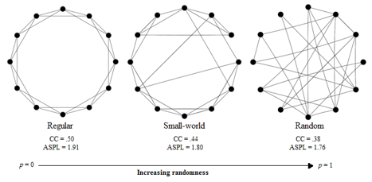Figure 1
Example of Network Types. Adapted from Watts and Strogatz (1998), this figure depicts examples of regular, small-world, and random networks. As the probability of random rewiring (p) increases, so to does the randomness of the connections in the network. A small-world network is situated between rigid structure and random connections.

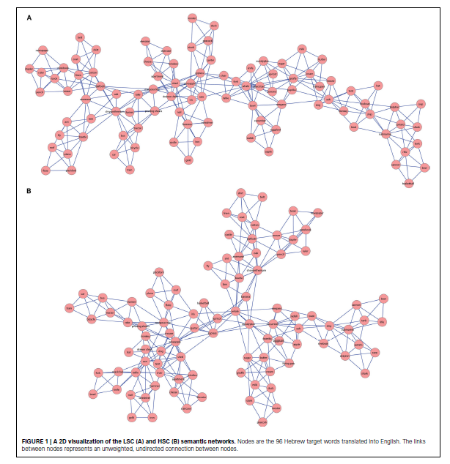Figure 2
High and Low Creative Semantic Networks. Semantic networks in low (A) and high (B) creative groups. Reprinted from Kenett et al. (2014).

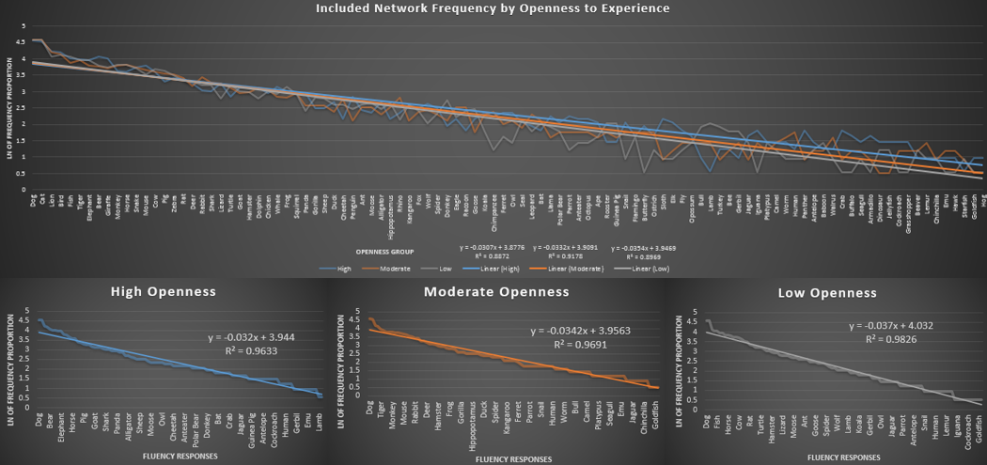
Figure 3
Association Slope Across and Within-Groups. Log-transformed frequency proportions plotted for comparison across groups (top) and each log-transformed frequency proportions of each openness group (bottom): high (right), moderate (middle), and low (bottom). The x-axis for the comparison across groups is ordered from the most common response to the least common response and displays each individual response. The x-axis for each group’s frequency proportion graphs are ordered from the most common response to the least common response within that group and displays every other response.
70

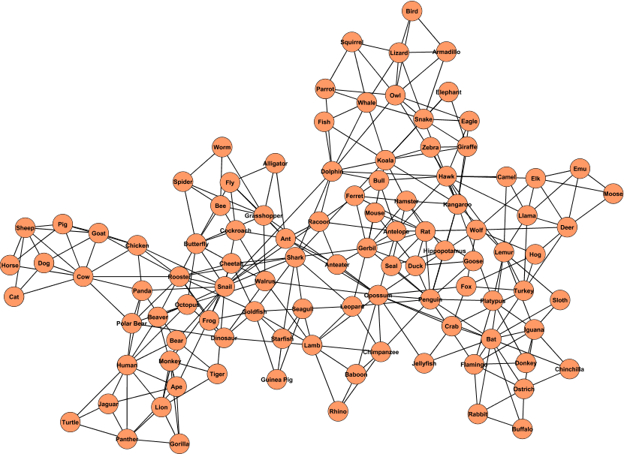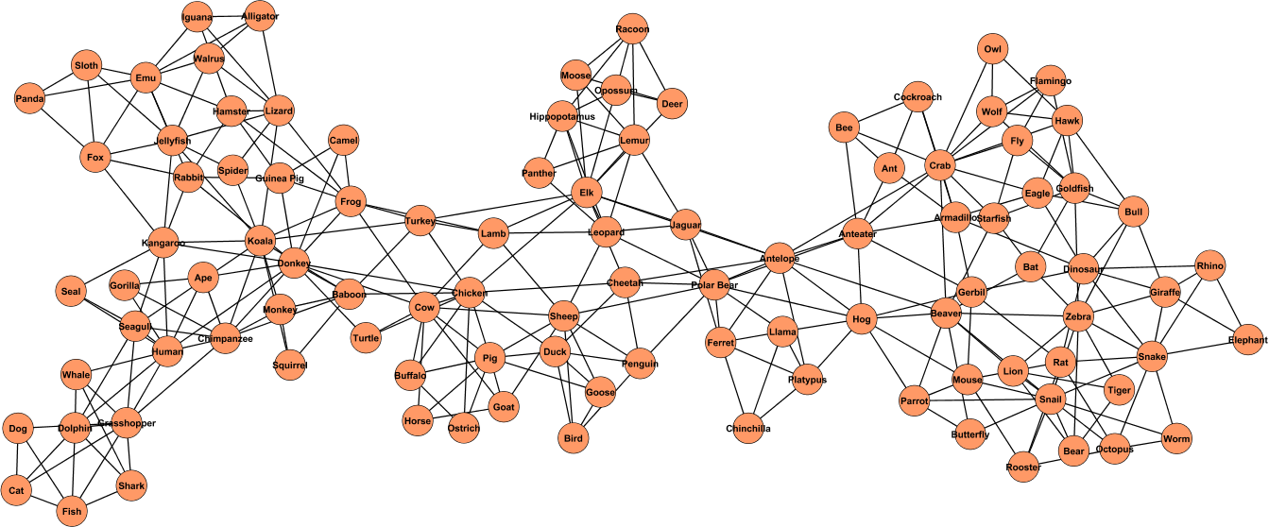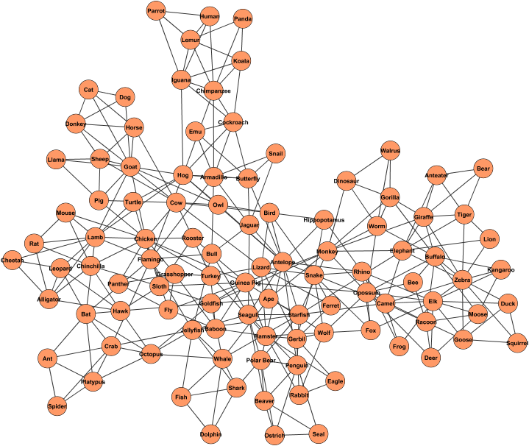
Figure 4
Full Semantic Network Structure of Each Group. Full semantic network structure of each openness group: high (top), moderate (middle), and low (bottom).

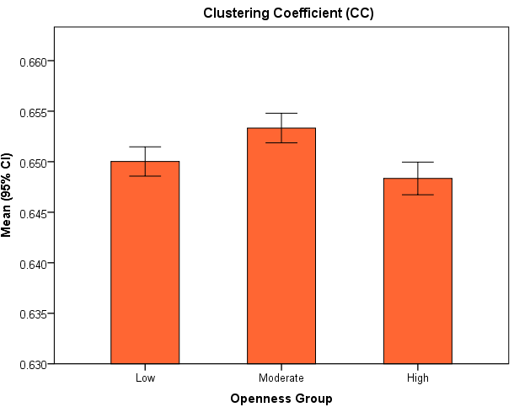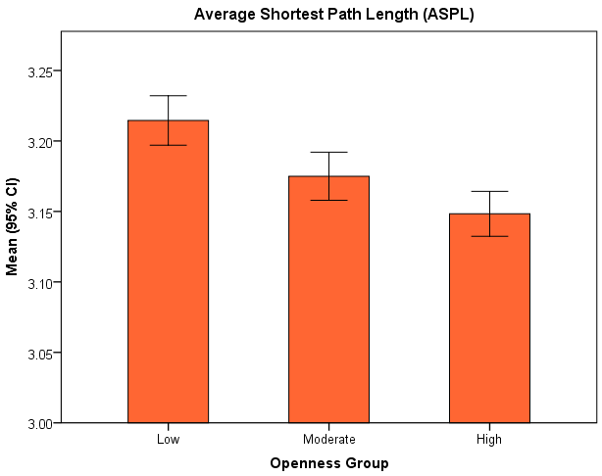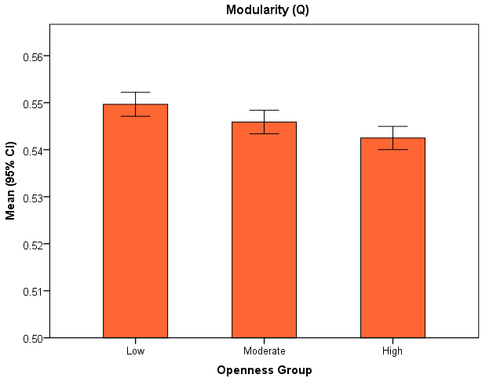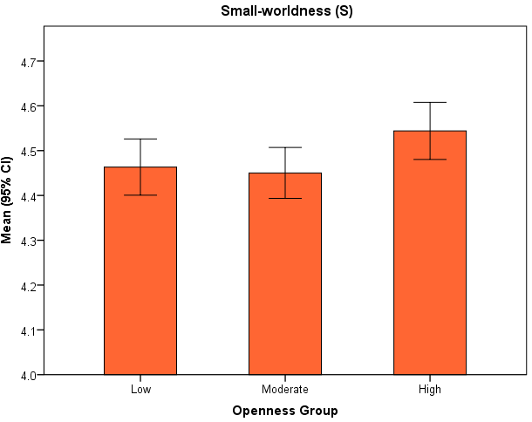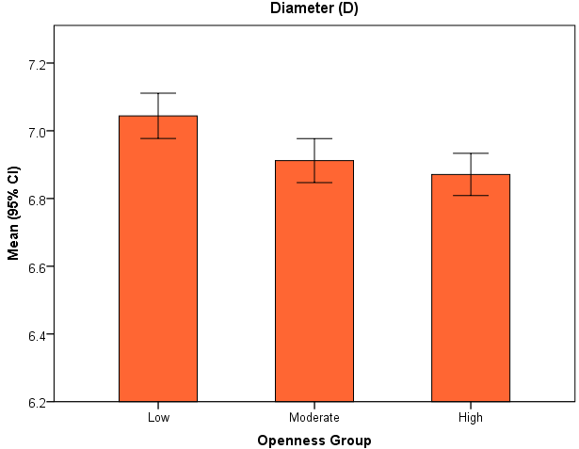
Figure 5
Bootstrapped Partial Network ANOVAs. Error bars represent 95% confidence intervals.

